**Homework 2**

Problem 1.

Use semantic HTML and create a Web Page like the following. Choose your own idea and picture.

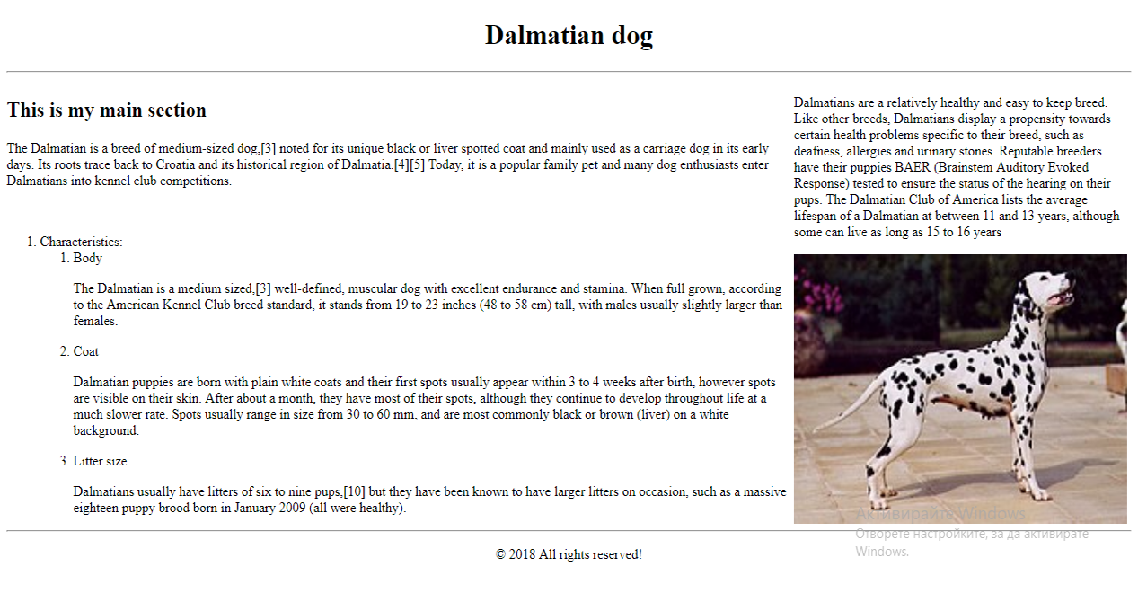

Problem 2.

Create a Web Page like the following.

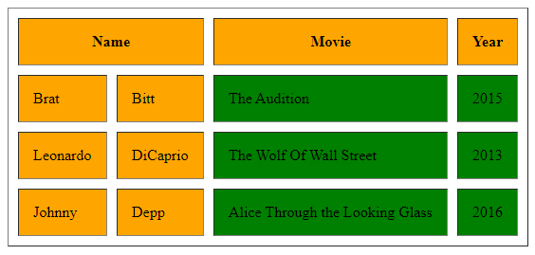

You can find the colors from here: <https://www.w3schools.com/css/css_colors.asp>

Problem 3.

Create Web Page with **TOP 3** of your favorite movies.

